1.First you need to order feature file like this way : with proper Naming convention with Digit
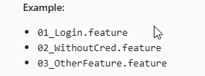
2. Then create scenario Sequentially with Original testcase ID (From Manual Test cases) :
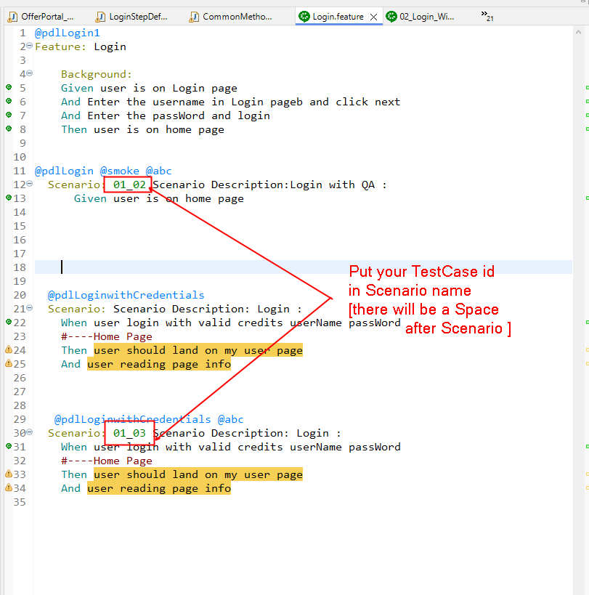
3. Use “@FixMethodOrder(MethodSorters.NAME_ASCENDING)” annotation write before the class name
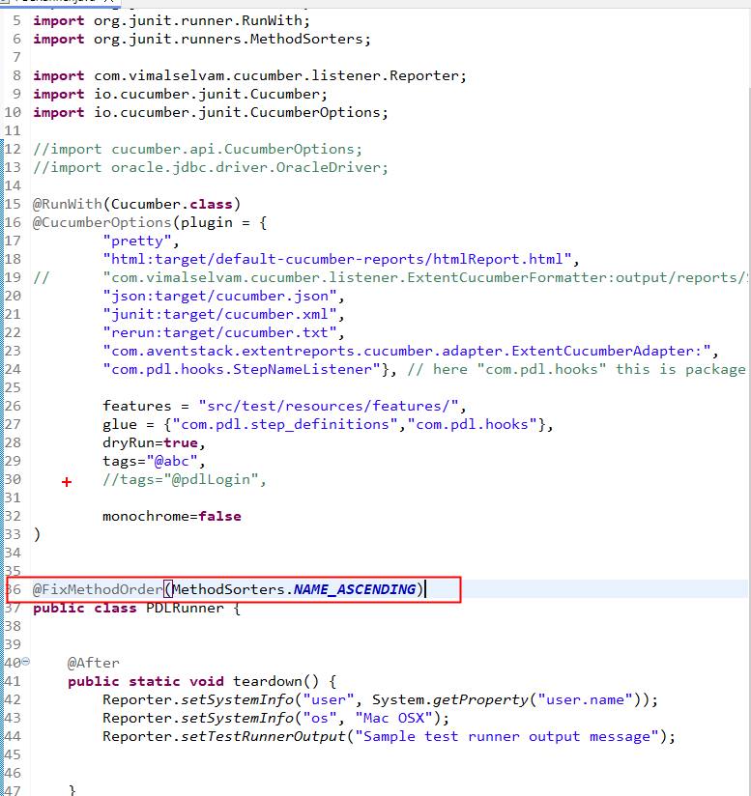

4. 